Map for Schools

MUSEUM FIRST FLOOR

- The Archive
- Learning Space A (Interactive sessions)
- Learning Space B (Lunch room)

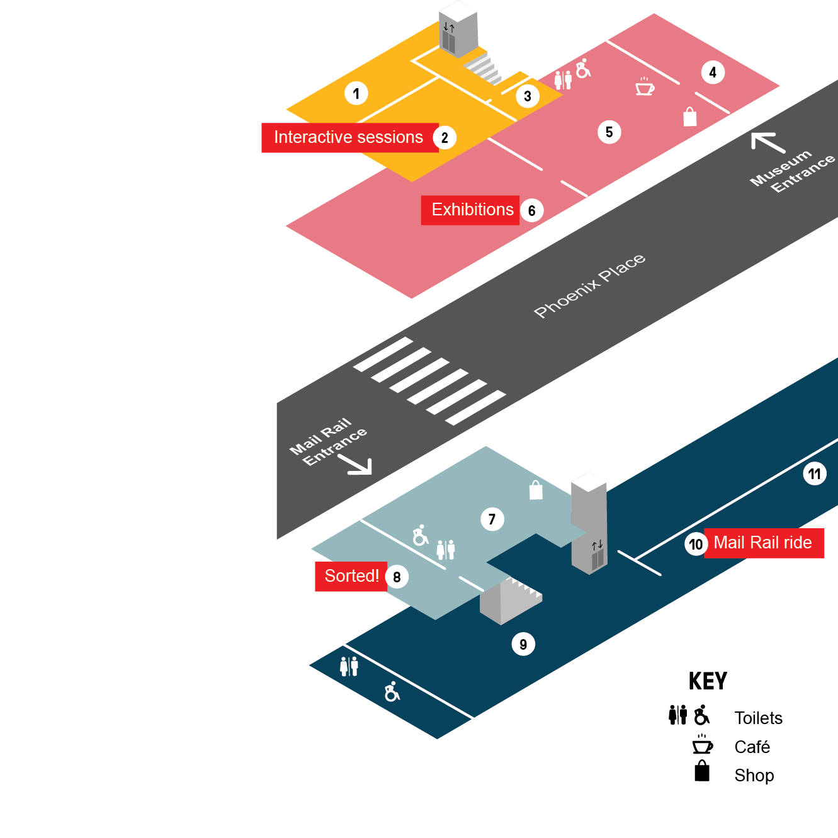
MAIL RAIL GROUND FLOOR

- Mail Rail depot
- Mail Rail ride and exhibition
- Mail Rail Accessible film
MAIL RAIL GROUND FLOOR

- Mail Rail Welcome Space
- Sorted! The Postal Play Space
MUSEUM GROUND FLOOR

- Courtyard
- Welcome Space
- Exhibitions

